**2**

**Template**

**Brainstorm**

Write down any ideas that come to mind that address your problem statement.

**10 minutes**

**3**

**Group ideas**

Take turns sharing your ideas while clustering similar or related notes as you go. In the last 10 minutes, give each cluster a sentence-like label. If a cluster is bigger than six sticky notes, try and see if you and break it up into smaller sub-groups.

**TIP**

You can select a sticky note and hit the pencil [switch to sketch] icon to start drawing!

**20 minutes**

**4**

**Prioritize**

Your team should all be on the same page about what's important moving forward. Place your ideas on this grid to determine which ideas are important and which are feasible.

**20 minutes**

**After you collaborate**

You can export the mural as an image or pdf to share with members of your company who might find it helpful.

# LALITHA

**ANITA**

**Sai**

**Quick add-ons**

1. **Share the mural**

Study the past and future problems

Conclude with an exact solution

Reach customer on a common platform

Set a backup plan

Proper usage of the resources

Clear view over the real time problem

Track the process regularly

**Share a view link** to the mural with stakeholders to keep them in the loop about the outcomes of the session.

Empower your customers

`Deliver the solution

1. **Export the mural**

Export a copy of the mural as a PNG or PDF to attach to emails, include in slides, or save in your drive.

Learn from failed procedures

Track individual’s performance

Cultivate customer centricity

Create additional context

Usage of motion sensors

**ARTHI**

Improve the process with new techniques

**JEEVITHA**

Never stop learning

Assess the situation

**Importance**

If each of these tasks could get done without any difficulty or cost, which would have the most positive impact?

Be more human

Understand what your customers want

**Keep moving forward**

**Strategy blueprint**

Usage of motion sensors

Meet customers often

Proper usage of the resources

Define the components of a new idea or strategy.

[**Open the template**](https://app.mural.co/template/e95f612a-f72a-4772-bc48-545aaa04e0c9/984865a6-0a96-4472-a48d-47639307b3ca)

Reach customer on a common platform

Stick to the process schedule

Track individual’s performance

**Customer experience journey map**

Understand customer needs, motivations, and obstacles for an experience.

[**Open the template**](https://app.mural.co/template/b7114010-3a67-4d63-a51d-6f2cedc9633f/c1b465ab-57af-4624-8faf-ebb312edc0eb)

**Strengths, weaknesses, opportunities & threats**

Learn from failed procedures

Ensure the availability of resources

Identify strengths, weaknesses, opportunities, and threats (SWOT) to develop a plan.

|  |  |
| --- | --- |
|  |  |
|  |  |

[**Open the template**](https://app.mural.co/template/6a062671-89ee-4b76-9409-2603d8b098be/ca270343-1d54-4952-9d8c-fbc303ffd0f2)

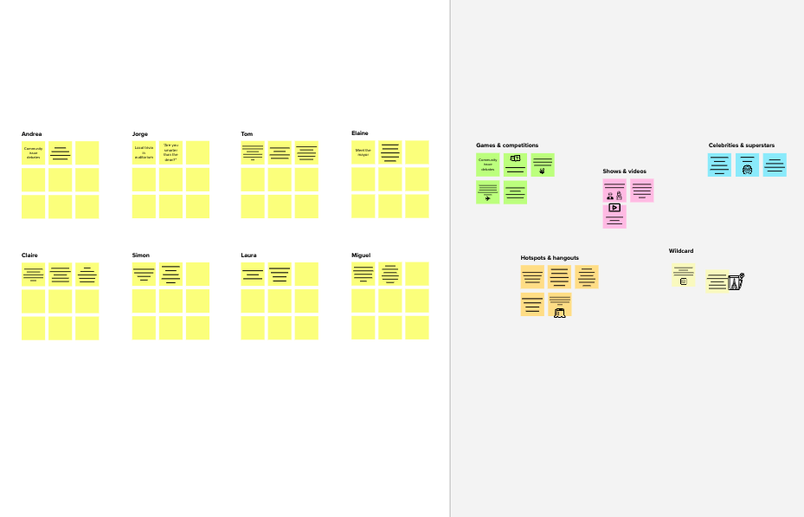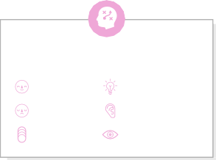

**1**

**Define your problem statement**

What problem are you trying to solve? Frame your problem as a How Might We statement. This will be the focus of your brainstorm.

**5 minutes**

**Key rules of brainstorming**

To run an smooth and productive session

Stay in topic.

Encourage wild ideas.

Defer judgment.

Listen to others.

Go for volume.

If possible, be visual.

**Need some inspiration?**

See a finished version of this template to kickstart your work.

[**Open example**](https://app.mural.co/template/e5a93b7b-49f2-48c9-afd7-a635d860eba6/93f1b98d-b2d2-4695-8e85-7e9c0d2fd9b9)

**C Learn how to use the facilitation tools**

Use the Facilitation Superpowers to run a happy and productive session.

[**Open article**](https://support.mural.co/en/articles/2113740-facilitation-superpowers)

**B Set the goal**

Think about the problem you'll be focusing on solving in the brainstorming session.

**A Team gathering**

Define who should participate in the session and send an invite. Share relevant information or pre-work ahead.

**Before you collaborate**

A little bit of preparation goes a long way with this session. Here’s what you need to do to get going.

**10 minutes**

[**Share template feedback**](https://muralco.typeform.com/to/CiqaHVat?typeform-source=app.mural.co)

**10 minutes** to prepare

**1 hour** to collaborate

**2-8 people** recommended

**Brainstorm**

**& idea prioritization**

Use this template in your own brainstorming sessions so your team can unleash their imagination and start shaping concepts even if you're not sitting in the same room.

**PROBLEM**

**Safe guarding the swimmers lives in swimming pools**



[**Share template feedback**](https://muralco.typeform.com/to/CiqaHVat?typeform-source=app.mural.co)

Learn about other related problems

Stick to the process schedule

Consider customer feedbacks

Meet customers often

Track customer requests everywhere

Use negative experiences to turn things around

Clear view over the real time problem

Study the past and future problems

Ensure the availability of resources

Track the process regularly

Listen to the customer and show genuine empathy

Make it easy to contact you

Improve the process with new techniques

Consider customer feedbacks

Learn about other related problems

**Feasibility**

Reach out using social media

Work toward personalization

Understand how you are performing

Empower your employees

Set a backup plan

Conclude with an exact solution

Regardless of their importance, which tasks are more feasible than others? (Cost, time, effort, complexity, etc.)